26.12.3 Editors - Properties Editor - Object Data Properties Tab - Surface Object
Detailed table of content 1
Shape panel 2
Resolution Viewport U / V 2
Render U / V 3
Texture Space panel 3
Texture Mesh 3
Auto Texture Space 3
Location and Size X / Y / Z 3
Match Texture Space 4
Active Spline panel 4
Cyclic U / V 4
Bezier U / V 4
Endpoint U / V 4
Order U / V 4
Resolution U / V 5
Smooth 5
Shape Keys panel 5
Workflow 5
Active Shape Key Index 6
Add + 7
Remove - 7
Specials menu 7
Relative 8
Custom Properties Panel 9
Add 9
Edit 9
Remove 9

Detailed table of content
Detailed table of content
Detailed table of content 1
Shape panel 2
Resolution Viewport U / V 2
Render U / V 3
Texture Space panel 3
Texture Mesh 3
Auto Texture Space 3
Location and Size X / Y / Z 3
Match Texture Space 4
Active Spline panel 4
Cyclic U / V 4
Bezier U / V 4
Endpoint U / V 4
Order U / V 4
Resolution U / V 5
Smooth 5
Shape Keys panel 5
Workflow 5
Active Shape Key Index 6
Shape Key name 6
Slider value 6
Lock 6
Drag Handler 6
Search Field 6
Invert 7
Sort by Name 7
Add + 7
Remove - 7
Specials menu 7
New Shape From Mix 7
Mirror Shape Key 7
Mirror Shape Key (Topology) 7
Join as Shapes (Transfer Mix) 7
Transfer Shape Key 7
Delete all Shape Keys 7
Move to Top 7
Move to Bottom 8
Move Shape Key Up / Down 8
Relative 8
Relative 8
Shape Key Lock (pin icon) 8
Shape Key Edit Mode (edit mode icon) 8
Value 8
Range 8
Vertex Group 8
Relative To 8
Absolute 8
Shape Key Lock (pin icon) 8
Shape Key Edit Mode (edit mode icon) 9
Re-Time Shape Keys (clock icon) 9
Interpolation 9
Evaluation Time 9
Custom Properties Panel 9
Add 9
Edit 9
Remove 9

Shape panel

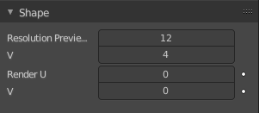
Resolution Viewport U / V
The 3D Viewport resolution of the generated mesh. The lower the higher the resolution.

Render U / V
The rendered resolution of the generated mesh. The lower the higher the resolution.

Texture Space panel

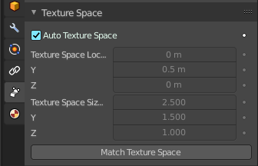
UV mapping can be generated. A procedural brick texture uses generated UV space for example to define the mapping.

In this panel you can adjust settings of the texture space used by generated texture mapping.
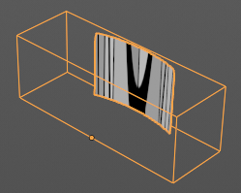




The display of the texture space cage can be activated in the Viewport Display in the Object properties.

Texture Mesh
Use another curve for texture indices. The vertex of the two objects must be perfectly aligned. Otherwise the UV map will be distorted. Note that, this is only for mesh objects.

Auto Texture Space
Adjusts the active object’s texture space automatically when transforming the object.

Location and Size X / Y / Z
Adjust the location and size of the texture space manually if Auto Texture Space is off.

The texture space can also be adjusted in the 3D Viewport. See Object Menu / Transform / Move and Scale Texture Space

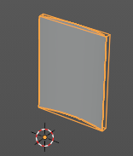
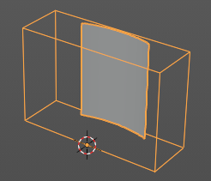
Match Texture Space
Match the texture space to the bounding box of the mesh part of the surface object, not the cage.

Active Spline panel

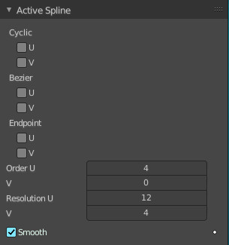
The Active Spline panel is used in Edit Mode to control properties of the currently selected spline.

U and V stands for the surface direction. U goes along the spline. V is the extruding direction.

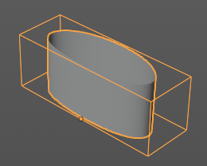
Cyclic U / V
Closes the active spline by connecting the end with the start point.

Bezier U / V
Make the nurbs curve or surface act like a Bezier spline in the U direction. Order U must be 3 or 4, and Cyclic U must be disabled.

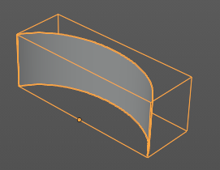
Endpoint U / V
Make the end points of the curve meet the end points of the handlers.

Order U / V
The area of influence of the control points over the curve. Higher order values means that a single control point has a greater influence over a greater relative proportion of the curve. The valid range of Order values is 2-6, depending on the number of control points present in the curve.
Two, three, four ...

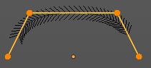
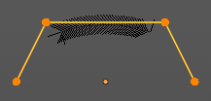
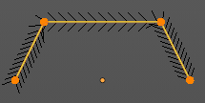

Resolution U / V
Alters the resolution of each segment by changing the number of subdivisions.

Smooth
Use Smooth Shading for any 3D geometry.

Shape Keys panel

This panel allows you to see and manage shape keys. A shape key is a vertex animation.
Shape keys are for example used for facial animations, when you don't want to use a face rig with bones. The idea is to model a shape key pose for smiling, one for laughing, one for sad, and so on. And then blend the shape key poses together as needed.

Shape keys are also called morph targets or blend shapes.

Workflow
In Object mode add a shape key. This first shape key is called Basis by default. It is the base for the vertex animation. This basis shape key is the base shape for all further shape keys. It cannot be modified or keyframed.

Now add a second shape key. This second shape key will have more controls so that you can modify it in the needed way.


Enter edit mode with this key 1 selected.
Modify the geometry by moving some vertices around. Shot is from a mesh, but works the same with curves.
Switch back to Object mode.


Have a look at the value slider. This slider defines how the key 1 shape key blends with the Basis shape key.
Move it from value 0 to value 1. You will notice that the vertices that you have modified in Key 1 will now start to move to a new position. Dependent of how strong the value is. With a value of 1 it will be at the position of how you modeled it.


To keyframe this shape click at the Animate property dot behind the slider. The slider will change its color. And the dot will change to a rhombus shape to indicate that there is a keyframe recorded at this frame.
Or you right click at the slider, and choose Insert Keyframe in the menu.
Move to another frame. Change the slider value, and set another keyframe.

Recorded keyframes can be found and further tweaked in the Dope sheet Editor in Shape Key Editor mode. Here you can also record further keyframes under Key / Insert Keyframes. And control the slider values from the channel list.

Add more shape keys and model and animate them as you need them.


Active Shape Key Index
A List of the shape keys for this mesh.
It contains two types of shape keys. Basis is the base shape. The other type relies at this shape as the base.

Shape Key name
The name of the shape key. It can be renamed by double clicking at it.

Slider value
The blend value of this shape key. The Basis shape key does not have such a slider.

Lock
The lock icon at the end of a group name locks the group from being editable.

Drag Handler
The two vertical lines at the end is a handler with which you can expand the list.

Search Field

You can expand a search field at the bottom of the list. Type in your term and hit enter to filter for your term.

Invert
Exclude the search term instead of searching for it.

Sort by Name
Sort the List by name.

Add +
Create a shape key.

Remove -
Delete the selected shape key.


Specials menu

New Shape From Mix
Add a new shape key with the current deformed shape of the object.

Mirror Shape Key
Mirror the shape keys on the X axis. This will not work if the mesh vertices is not fully symmetrical.

Mirror Shape Key (Topology)
Mirror the shape keys on the X axis. But detects the mirrored vertices based on the topology of the mesh. The mesh vertices do not have to be perfectly symmetrical for this action to work.

Join as Shapes (Transfer Mix)
Transfer the current resulting shape from a different object.
Select the object to copy, hold down Shift, then the object to copy into. Use this action and a new shape key will be added to the active object with the current mix of the first object.

Transfer Shape Key
Transfer the active shape key from a different object regardless of its current influence.
Select the object to copy, hold down Shift, then the object to copy into. Use this action and a new shape key will be added to the active object with the active shape of the first object.

Delete all Shape Keys
Delete all shape keys at this mesh.

Move to Top
Move the shape key to the top of the list. But not above the Basis shape key.

Move to Bottom
Move the shape key to the bottom of the list.


Move Shape Key Up / Down
Moves the selected shape key up or down in the list.

Relative
Set the shape keys to Relative or Absolute.


Relative
The shape is defined relative to the Basis or another specified shape key. And can be adjusted in its settings.

Shape Key Lock (pin icon)
Show the active shape in the 3D Viewport without blending. Shape Key Lock gets automatically enabled while the object is in Edit Mode.

Shape Key Edit Mode (edit mode icon)
If enabled, when entering Edit Mode the active shape key will not take maximum influence as is default. Instead, the current blend of shape keys will be visible and can be edited from that state.

Value
The weight of the blend between the shape key and its basis key. 0 means no influence, 1 full influence.

Range
Minimum and maximum range for the influence value of the active shape key.

Vertex Group
Limit the active shape key deformation to a vertex group.

Relative To
Select the shape key to deform from. It does not need to be the Basis shape key, but can also be another shape key.

Absolute

The shape changes over time, as defined in its settings.

Shape Key Lock (pin icon)
Show the active shape in the 3D Viewport without blending. Shape Key Lock gets automatically enabled while the object is in Edit Mode.

Shape Key Edit Mode (edit mode icon)
If enabled, when entering Edit Mode the active shape key will not take maximum influence as is default. Instead, the current blend of shape keys will be visible and can be edited from that state.

Re-Time Shape Keys (clock icon)
Absolute shape keys are timed, by order in the list, at a constant interval. This button resets the timing for the keys. Useful if keys were removed or re-ordered.


Interpolation
The interpolation method between shape keys.

Evaluation Time
Evaluate the shape key influence over the defined time. The evaluation starts at influence 0, and reaches 1 at the end of the value of this timer.

Custom Properties Panel


Here you can define custom properties that can be used for scripting.

Here you might also find custom properties from addons or scripts.

Add
Adds a new property.


Edit
Opens a panel where you can adjust the settings for the custom property.

Remove
Removes the property.

